**EXPERIMENT - 1**

**Aim:**

To create a simple cloud-based software application using Zoho Creator and provide it as a service to users, thereby demonstrating the concept of Software as a Service (SaaS).

**Procedure:**

1. Login to Zoho Creator using your Zoho account.
2. Create a new application → Select “Create from scratch”.
3. Name the application (e.g., *Student Feedback System*).
4. Design the Form (data entry screen):
   * Add fields such as *Name, Email, Course, Feedback (text), Rating (1–5)*.
5. Build the Report to view stored feedback in a table/dashboard format.
6. Customize Workflow (optional): send an email alert when new feedback is submitted.
7. Share the Application with users via a web link. Users can access it from anywhere via the internet without installation.
8. Test the SaaS functionality by submitting data from a different user account.

**Output:**

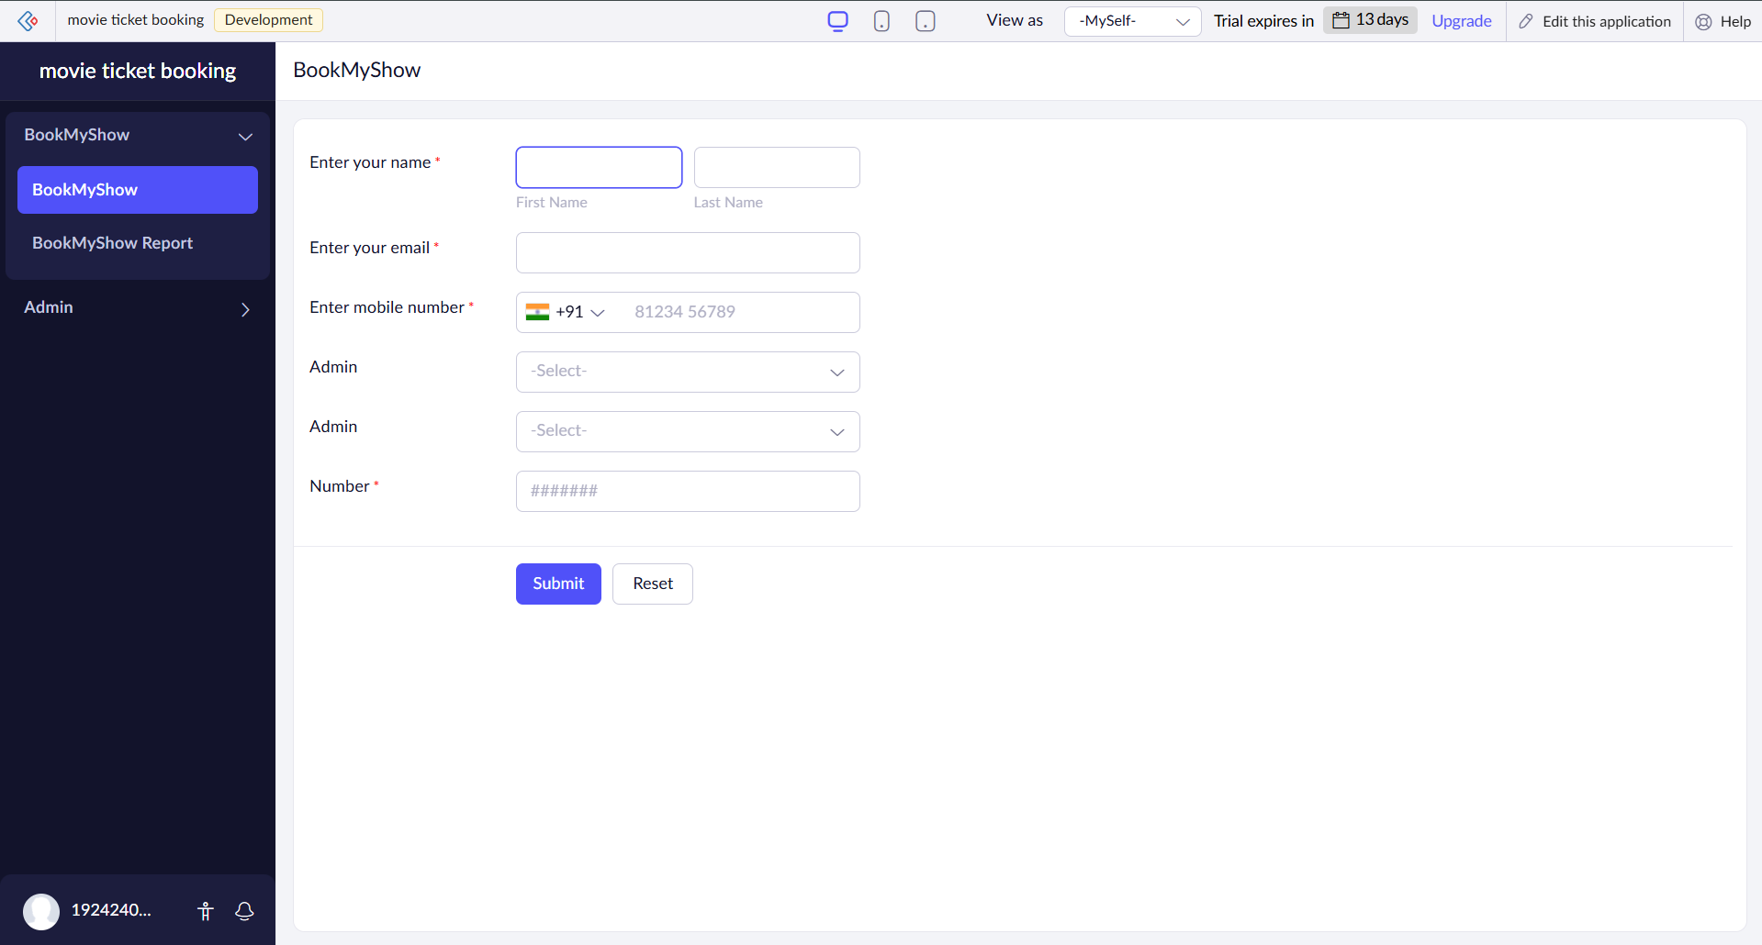

**Result:**

A simple cloud-based feedback collection system was successfully created and deployed using Zoho Creator. The application can be accessed online by multiple users, proving the concept of Software as a Service (SaaS) where software is hosted on the cloud and delivered over the internet.